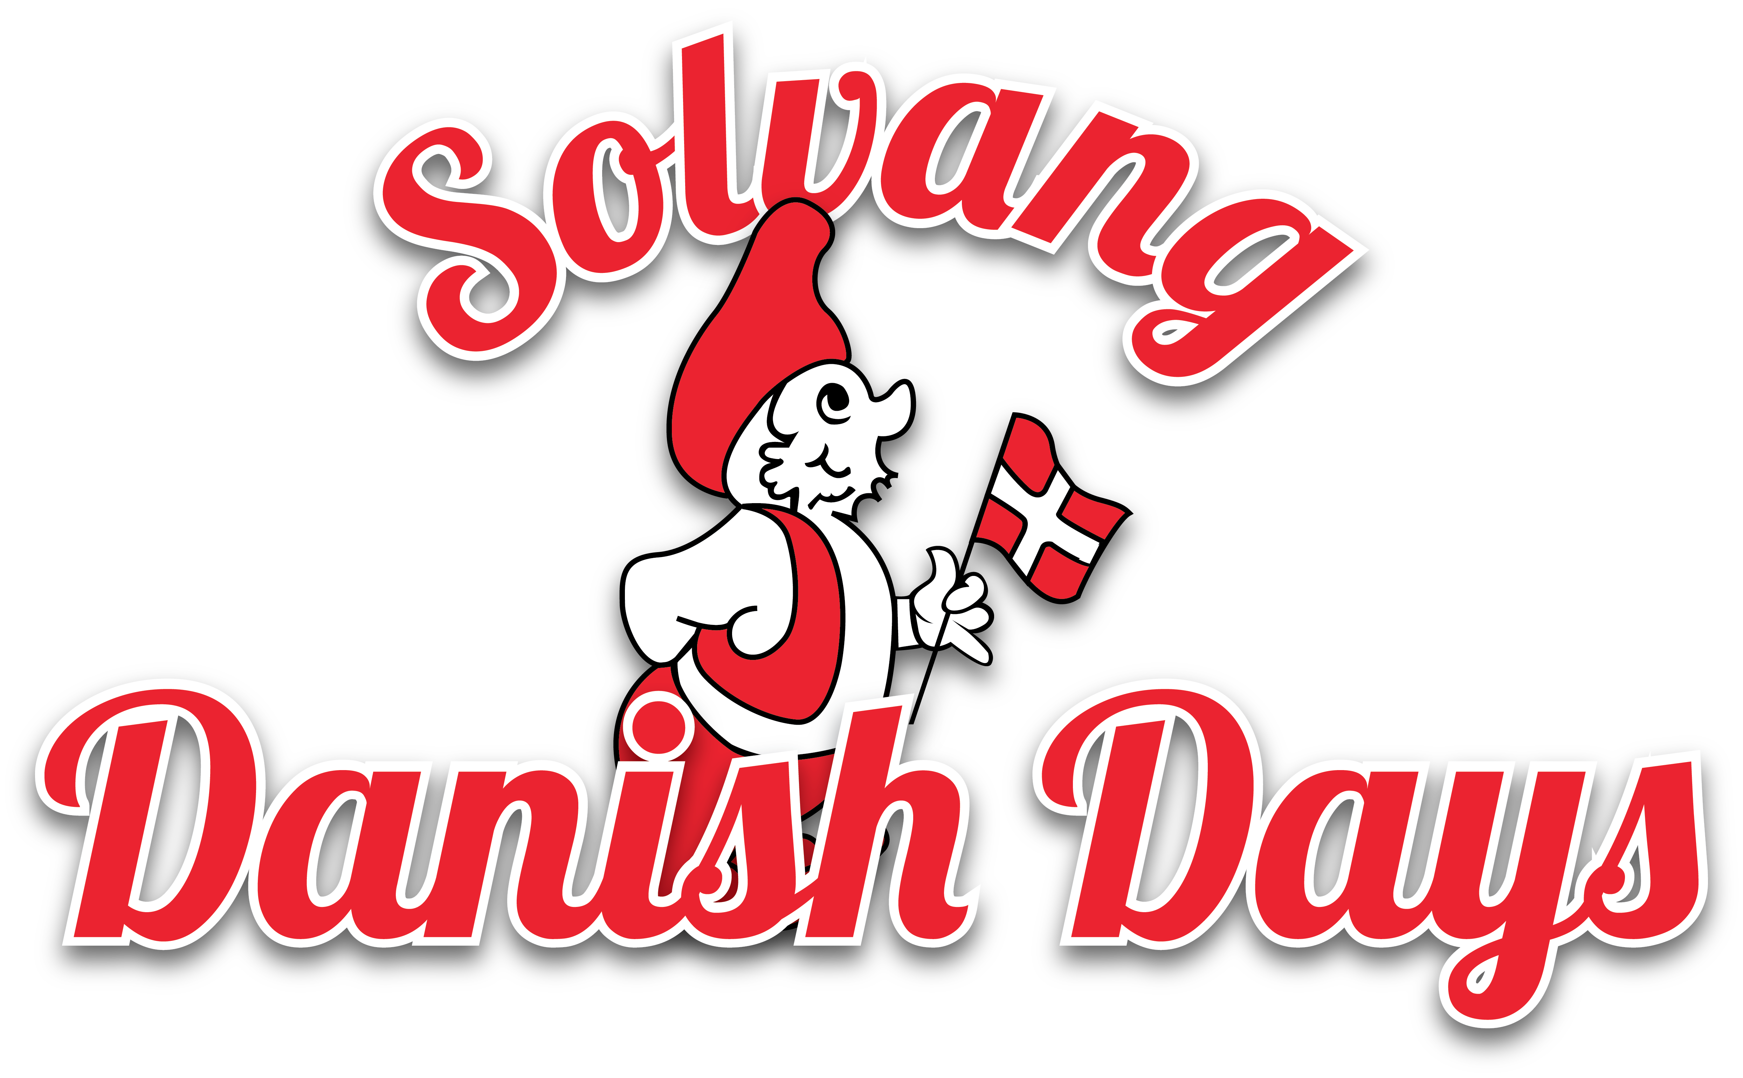
www.SolvangDanishDays.org

2014 DANISH DAYS PARADE APPLICATION
Thank you for your request for an application for this year’s Danish Days Parade. The theme for our 78th year is “Solvang – Sunny Field of Dreams” The parade is Saturday, September 20, 2014 at 2:30pm (Line up starts at 1:30pm on First Street between Molle Way and Elverhoy; parade begins by turning east on Copenhagen Drive, then north on Alisal Road, west on Mission Drive, south on Fourth Place, east on Copenhagen; south on Second Street, finishes at corner of Oak Street (near Solvang City Hall). As always, everyone is invited to join the fun! There is NO CHARGE to participate in the parade.

Marching Bands – School Bands – Groups – Individuals –Businesses– Non-Profits– Equestrian*– Historical

Please complete this form and return by mail to:
Solvang Danish Days Foundation
Mark & Maggie Ream, 2014 Parade Co-Chairs
320 Alisal Rd #104
Solvang, CA 93463
OR by FAX to 805-686-9587
OR scan and return by email to: solvangdanishdaysparade@gmail.com

Name of entry:___________________________________________________________

Contact person:___________________________________________________________

Full Address:_____________________________________________________________

Phone:___________________Email: _________________________________________________________

Type of entry:____________________________________________________________

Brief description and commentary about your entry for announcer: (50 words suggested)
________________________________________________________________________________________________________________________________________________________________________________________________________________________________________________________________________________________________________________________________________________________________________
*Equestrian entries please note: “Pooper Scooper” personnel are required by the City for each entry.

Again, thank you for your request and we look forward to having you join us for the 2014 Danish Days Parade. If you have any question please contact us at 805-686-9376 or danishdaysparade@gmail.com

Sincerely,
Mark & Maggie Ream, Volunteers, 2014 Danish Days Parade Co-chairs

